Councillors on this Committee:

EX OFFICIO Cllr. L Symonds (Chair of Council), Cllr. D Seabrook (Vice Chair of Council),

Cllr L Duhigg (Chairman), Cllr W Veck (Vice chair), Cllr E Simmons, Cllr L Symonds, Cllr J Harris, Cllr G Hill,
Cllr K Sanderson

19th October 2022

Dear Committee Member,

You are summoned to a meeting of the Civic and Community Events Committee which will be held in the Anzac Room, Community House, Peacehaven on Tuesday 25th October 2022 commencing at 7.30pm

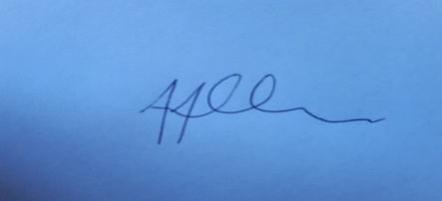
Tony Allen
Town Clerk
A G E N D A

- CCE225 CHAIRMAN’S ANNOUNCEMENTS

- CCE226 PUBLIC QUESTIONS
There will be a 15-minute period whereby members of the public may ask questions, on any relevant Civic & Community Event matters

- CCE227 TO CONSIDER APOLOGIES FOR ANY ABSENCES AND SUBSTITUTIONS

- CCE228 TO RECEIVE DECLARATIONS OF INTERESTS FROM COMMITTEE MEMBERS

- CCE229 TO ADOPT THE MINUTES OF 6TH SEPTEMBER 2022

- CCE230 TO NOTE THE BUDGETARY UPDATE AND DISCUSS DRAFT 2022/24 BUDGET

- CCE231 VERBAL UPDATE ELECTION OF THE YOUTH MAYOR

- CCE232 TO NOTE AND AGREE FORMAT FOR FUTURE WRESTLING EVENTS

- CCE233 TO DISCUSS MONTHLY BINGO AT COMMUNITY HOUSE

- CCE234 TO RECEIVE A VERBAL UPDATE ON THE ORGANISATION OF ARMISTICE AND REMEMBRANCE DAY

- CCE235 TO DISCUSS AND AGREE BI-ANNUAL SUMMER FAYRE

- CCE236 VERBAL UPDATE ON HALLOWEEN EVENT ON 29TH OCTOBER 2022

- CCE237 TO NOTE THE UPDATED EVENTS CALENDER

DATE OF NEXT MEETING OF THE COMMITTEE – 13TH DECEMBER 2022

