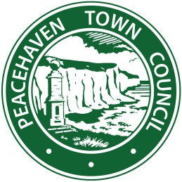

PEACEHAVEN CALENDAR COMPETITION 2021
Entries are now open for the 2021 Peacehaven Calendar photographic competition.
Peacehaven Town Council would like to invite residents to send in their Bright and Beautiful images of Peacehaven.
Name
Address
Age (if under 16)
Contact No.
Email
Method of transferring images
Amount of photos taken

PEACEHAVEN CALENDAR COMPETITION 2021
TERMS AND CONDITIONS
- Photographs can be in colour/sepia/black & white
- All photographs (if emailed/uploaded to us) must be in the highest resolution possible
- If uploading more than 6MB worth of photos, we suggest you pass them on using a USB, as the transfer time could delay the process
- All entries should be captioned, with the appropriate information (Location, Date)
- You may enter as many photos as you wish
- You can pass photos onto the council by hard copies, email, USB or social media
- The closing date of the competition will be 18th October 2020
- The winning photographs will go into the PEACEHAVEN CALENDAR 2021
- The photo must be in its original state and cannot be altered in any way, including but not limited to removing, adding, reversing, or distorting subjects within the frame.
- Entries will be judged by the Mayor of Peacehaven All decisions are final. The Council reserves the right to disqualify any entry that is deemed inappropriate or does not conform to stated contest rules.
- Photographers will retain copyright for their photos, however if Peacehaven Town Council wish to use them for promotion, they have the right do so. Photographers will be credited appropriately, where possible
- Submissions will not be accepted once the deadline lapses.
- The contest is void where prohibited or restricted by law.

